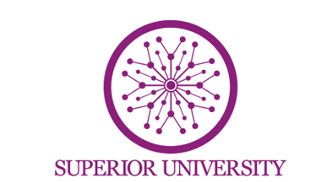
Name: Muzamil Mushtaq
Roll no: SU92-BSAIM-F24-037
Section: BSAI-4A
Submitted To: Sir Rasikh Ali
Lab_Task_12
Topic: University Admission Chatbot (AI-Based QnA System Using Flask, FAISS and MiniLM)

Introduction:
The University Admission Chatbot is an AI-based web application developed using Flask for the backend and HTML/CSS for the frontend. The main purpose of this chatbot is to provide students with quick and accurate information regarding university admissions.
This system uses Natural Language Processing (NLP) techniques along with transformer-based embeddings (MiniLM model from Hugging Face) to understand user queries. Instead of using simple rule-based responses, the chatbot performs semantic search using FAISS (Facebook AI Similarity Search) to find the most relevant answer from the dataset.
Objectives:
- To develop an intelligent chatbot for university admission queries.
- To implement NLP-based semantic search using MiniLM embeddings.
- To store and search vector data efficiently using FAISS.
- To create a user-friendly web interface using Flask, HTML, and CSS .
- To improve traditional rule-based chatbot systems using AI techniques.
Technologies Used:
- Python.
- Flask (Backend framework).
- HTML/CSS (Frontend design).
- Sentence Transformers (MiniLM model for embeddings).
- FAISS (Vector similarity search library).
- NumPy (Numerical operations).
Working Methodology:
The system works in the following steps:
- The user enters a question in the chatbot interface.
- The input text is converted into a vector using the MiniLM embedding model.
- FAISS compares this vector with stored question vectors in the database.
- The most similar question is retrieved based on similarity score.
- The corresponding answer is returned and displayed to the user.
Features of the System:
- AI-based semantic understanding of queries.
- Fast and efficient search using FAISS.
- Simple and interactive web interface.
- Predefined university admission knowledge base.
- Real-time response system.
- Scalable architecture for future improvements.
Advantages:
- More intelligent than traditional rule-based chatbots.
- Provides accurate answers based on meaning, not just keywords.
- Fast response due to FAISS vector indexing.
- Easy to extend with more data.
- Improves user experience in university admission guidance.
- Reduces workload of administrative staff.
Disadvantages:
- Requires computational resources for embedding models.
- Limited accuracy if dataset is small.
- Dependency on pre-trained models (MiniLM).
- Not fully capable of handling complex conversational reasoning.
- Needs proper dataset management for better results.
Applications:
- University admission assistance systems.
- Educational information chatbots.
- Customer support systems.
- FAQ automation systems.
- AI-based knowledge retrieval systems.
Future Improvements:
- Integration with large language models (LLMs) like GPT.
- Voice-based interaction system.
- Database integration for dynamic updates.
- Multi-language support (English + Urdu).
- Deployment on cloud platforms for public access.
- Chat history and user authentication system.
Conclusion:
The University Admission Chatbot is an advanced AI-based system that demonstrates the practical use of Natural Language Processing, transformer models, and vector similarity search. By combining Flask, MiniLM, and FAISS, the system provides a fast and intelligent way to retrieve answers from a knowledge base.
This project improves traditional chatbot systems by introducing semantic search instead of keyword matching. It is a scalable and efficient solution that can be further enhanced using modern AI technologies.

Thank you for viewing my work…..

